

|  |
| --- |
| **AWS Cloud Data Services** |
|  |
|  |

1. RDS MYSQL

Connected and new user created with all necessary permissions.

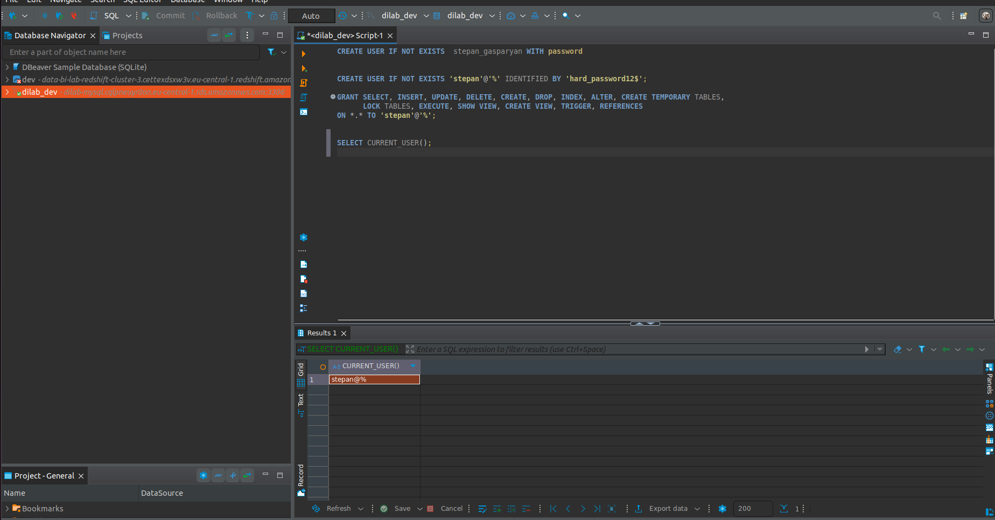

Schema and table created

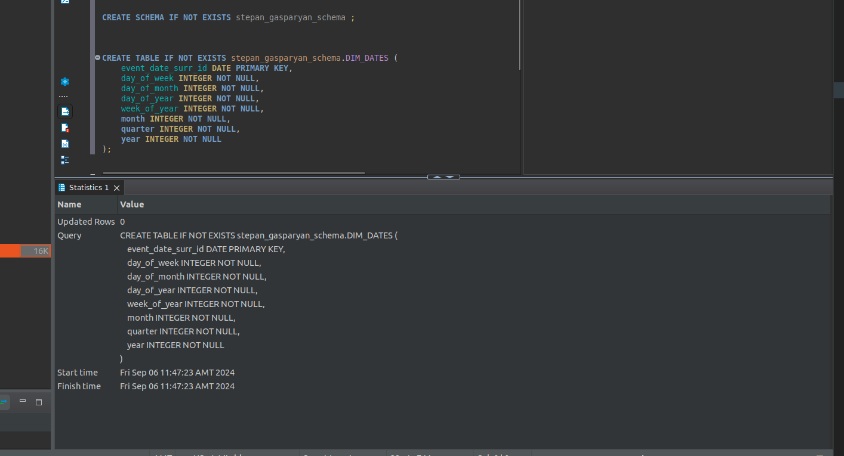.

Procedure to load some data into table

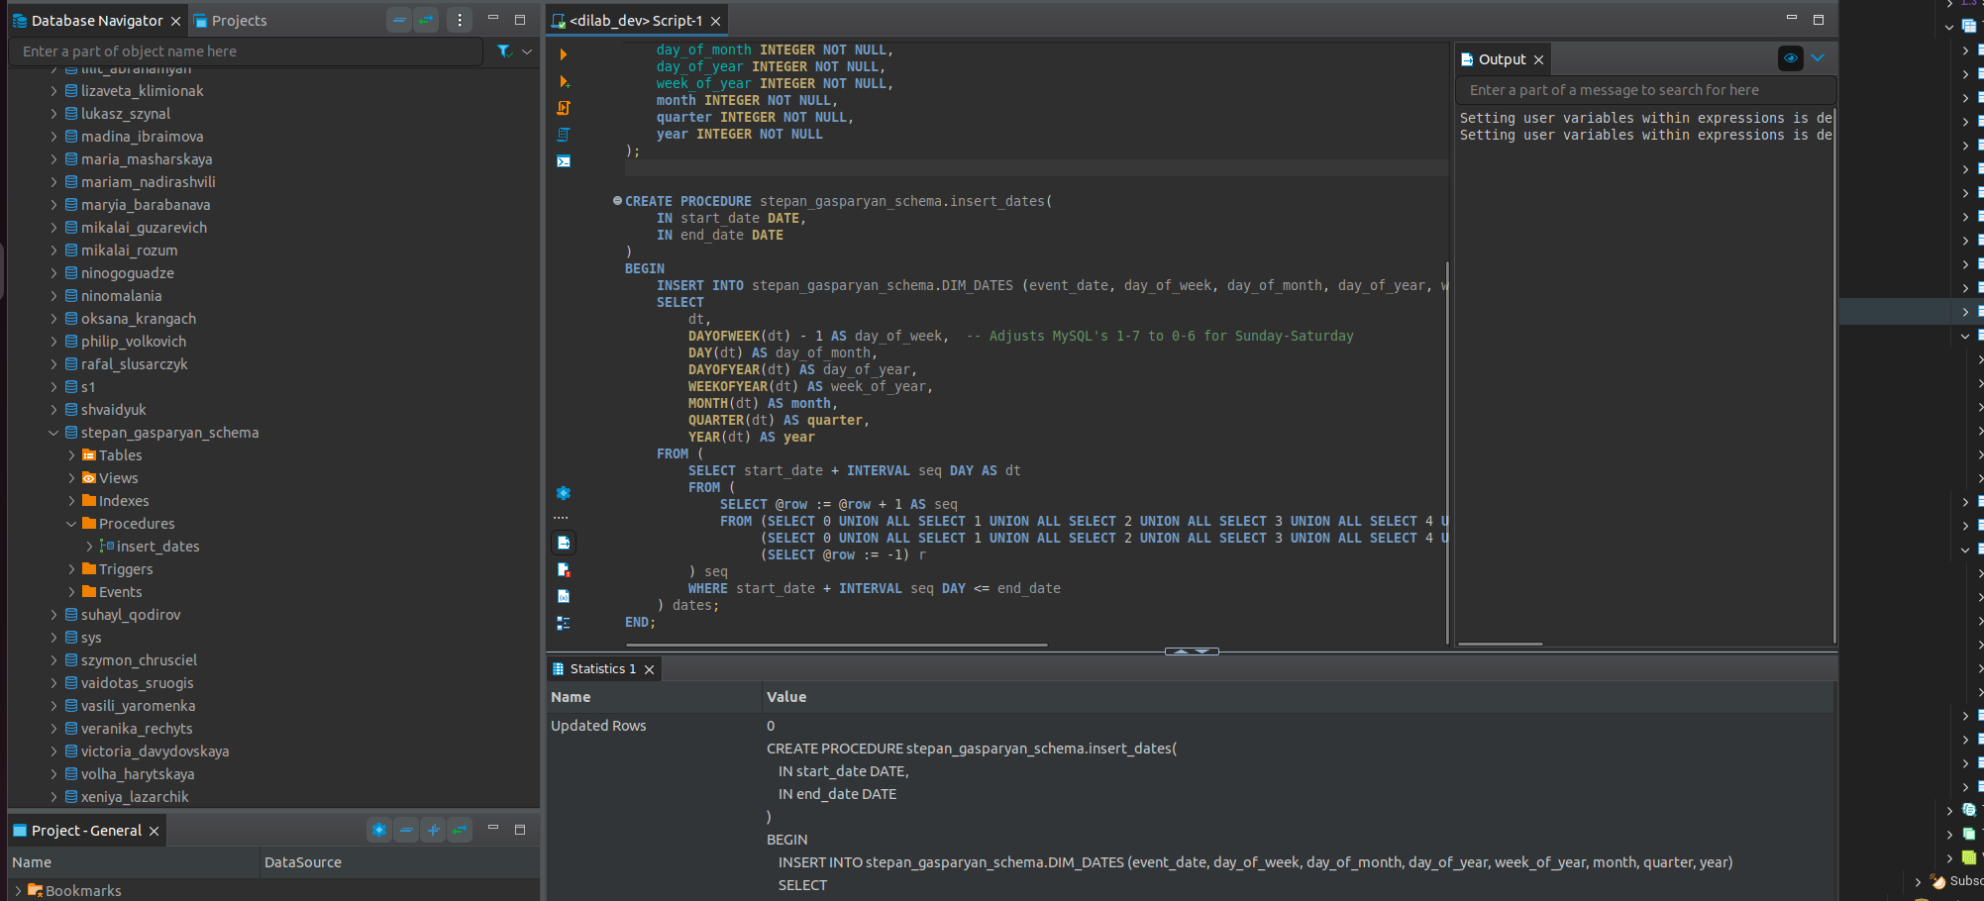

Loaded

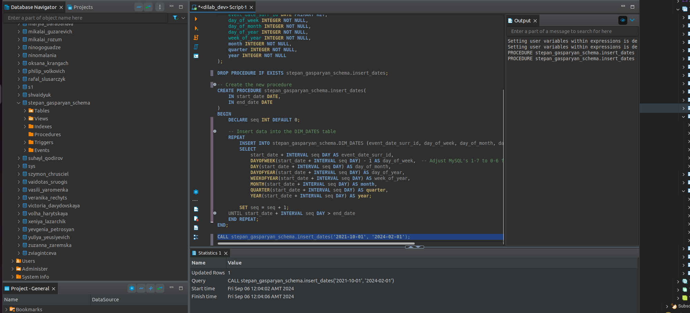.

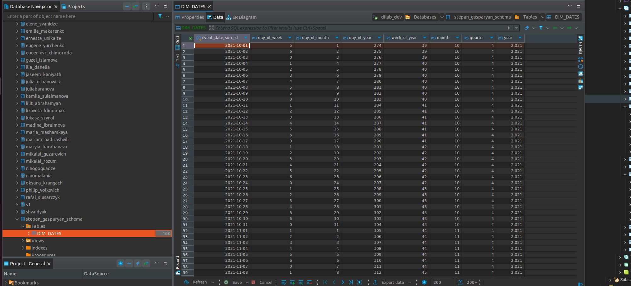.

2. RDS Aurora

Schema and table created in Aurora

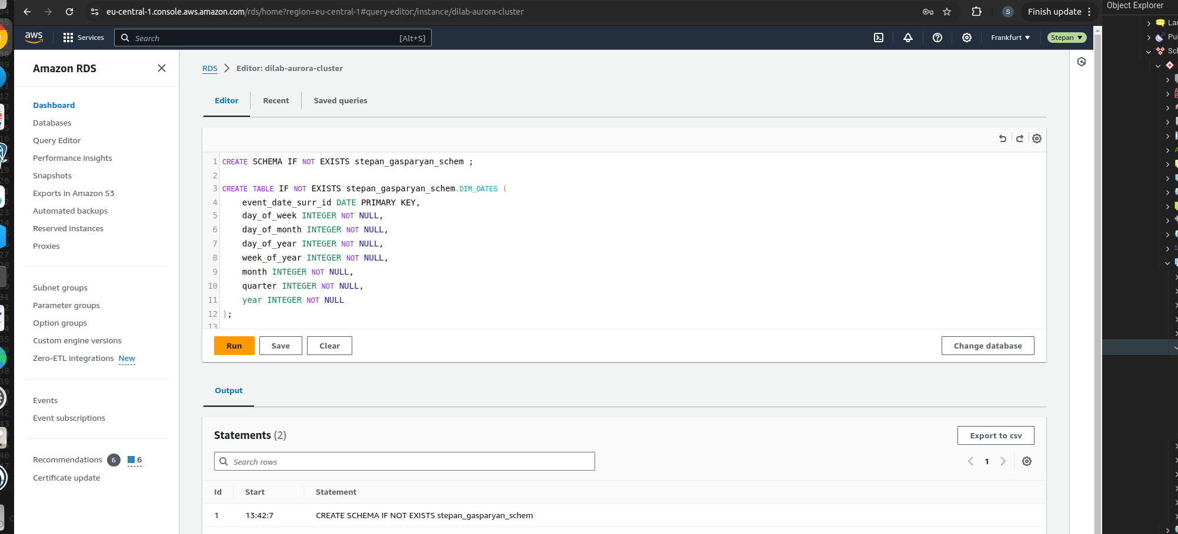.

Connecting to Aurora from my pc using SSH tunnel.

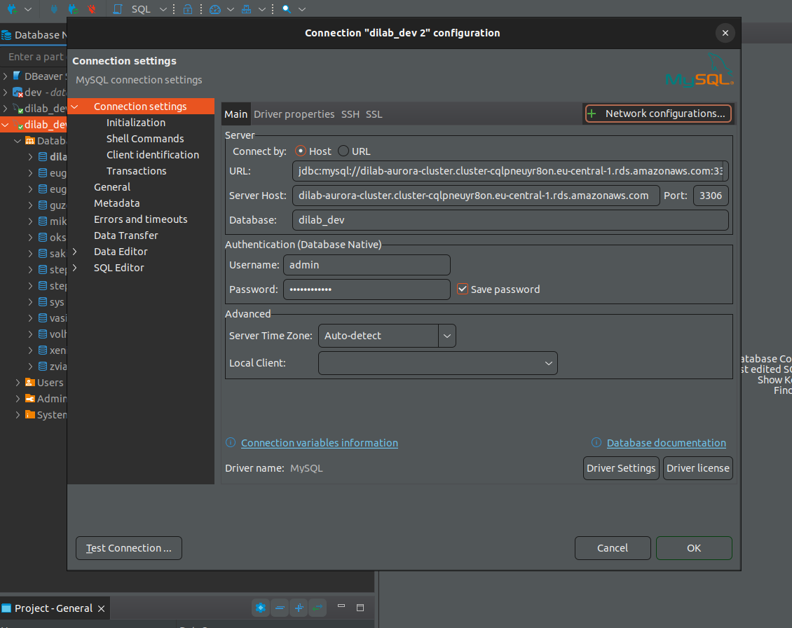.

SSH configs

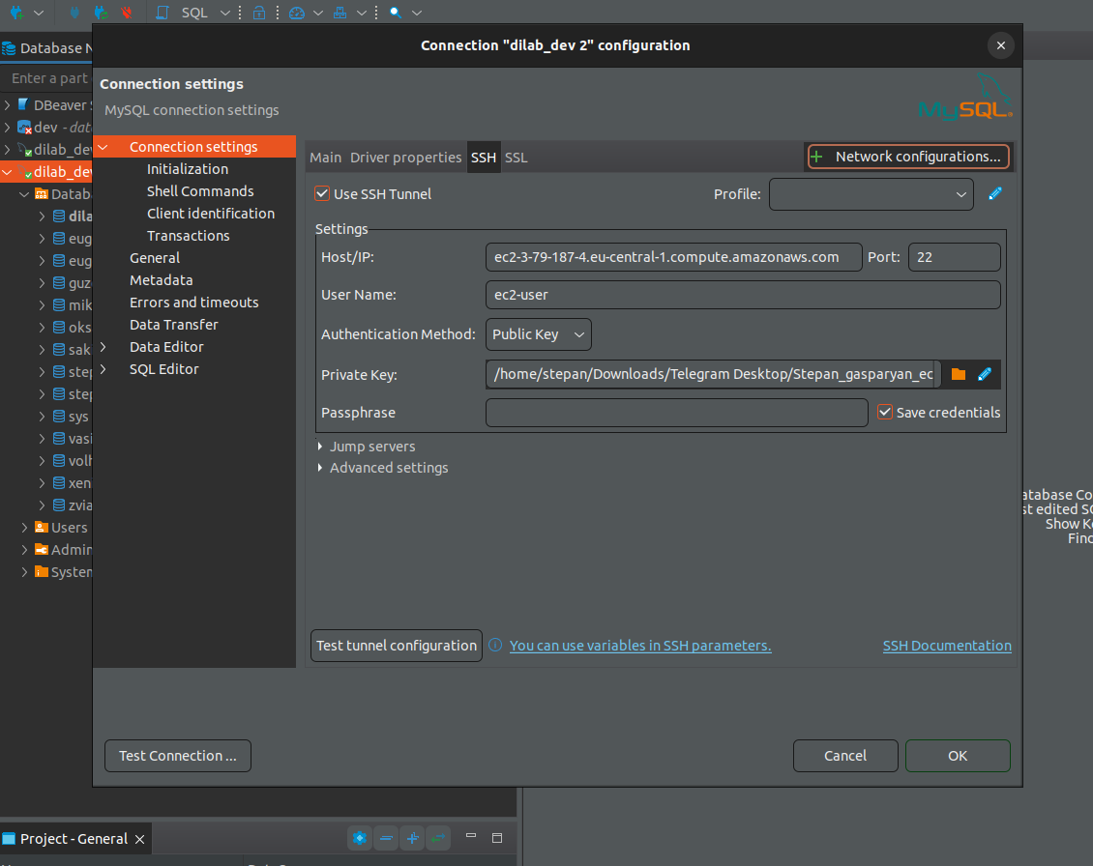We can’t connect directly to Aurora db because connection is not allowed from public and we need to connect to EC2 which is in same VPC subnet with Aurora db.

3. DynamoDB

Table created from AWS console

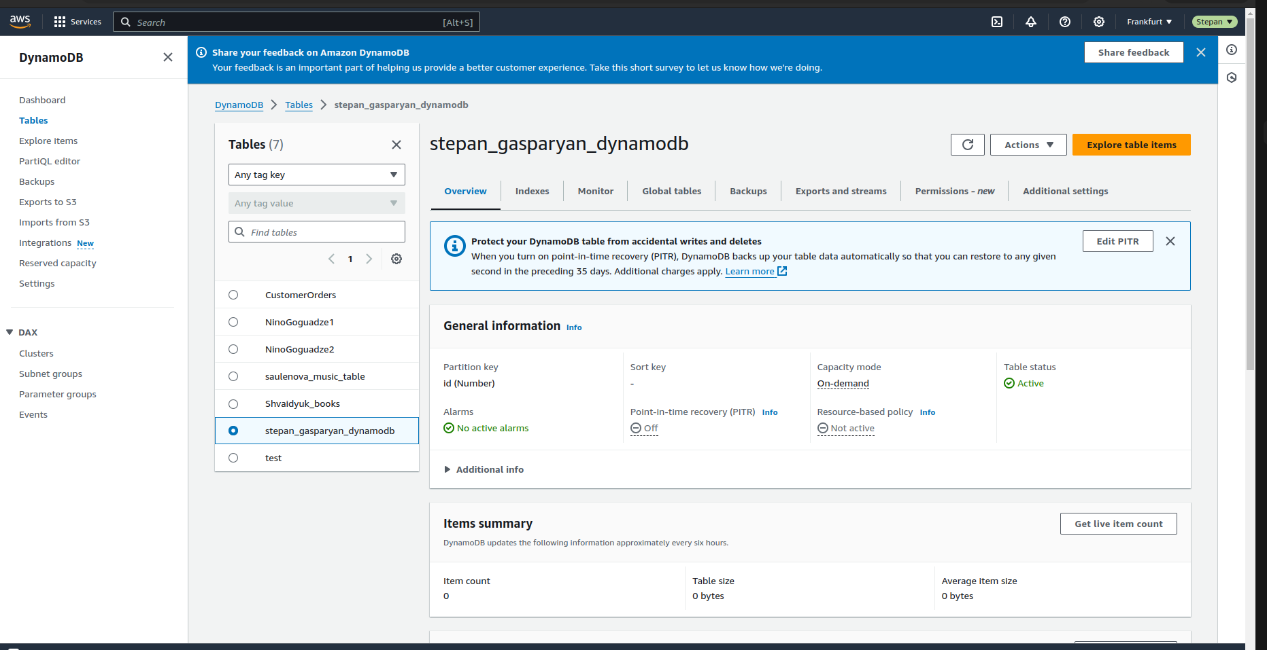

Table item created

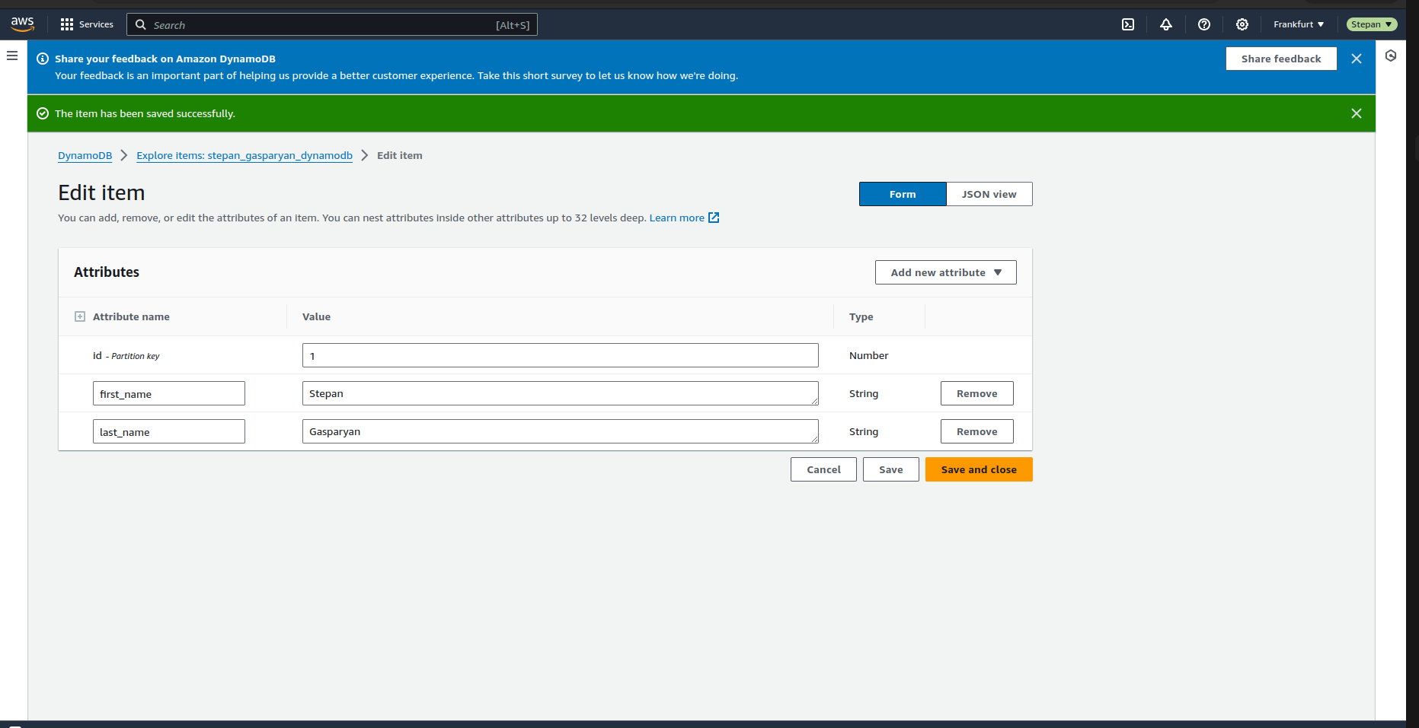.

To load 20 record into dynamo db table I created Json file`

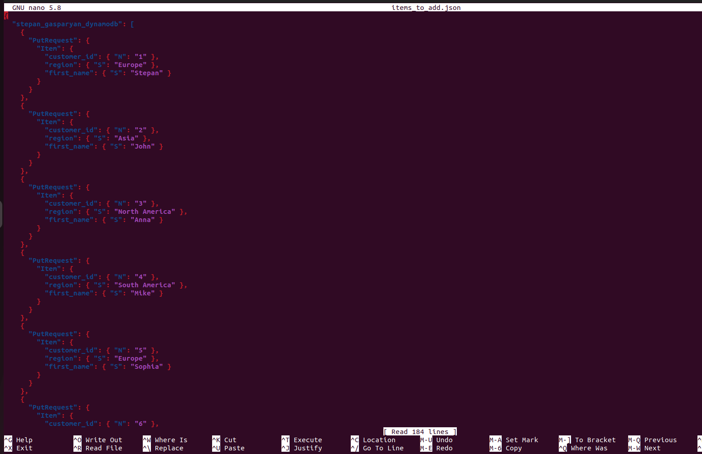.

For single record I use this command to put item into it`

aws dynamodb put-item --table-name stepan_gasparyan_dynamodb --item '{"customer_id": {"N": "1"},"region":{"S":"Europe"}, "first_name": {"S": "Stepan"}}' --profile students-role

And run this`

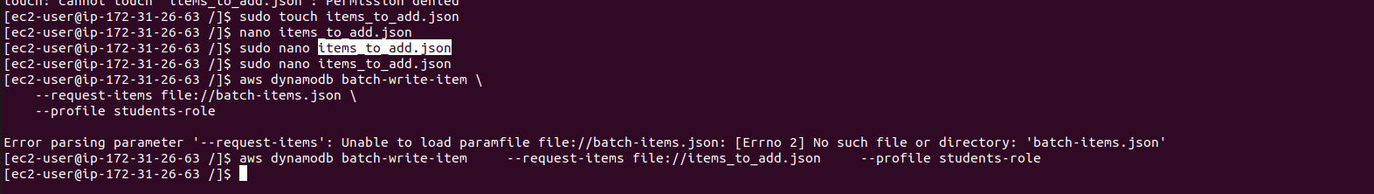.

Here is loaded records

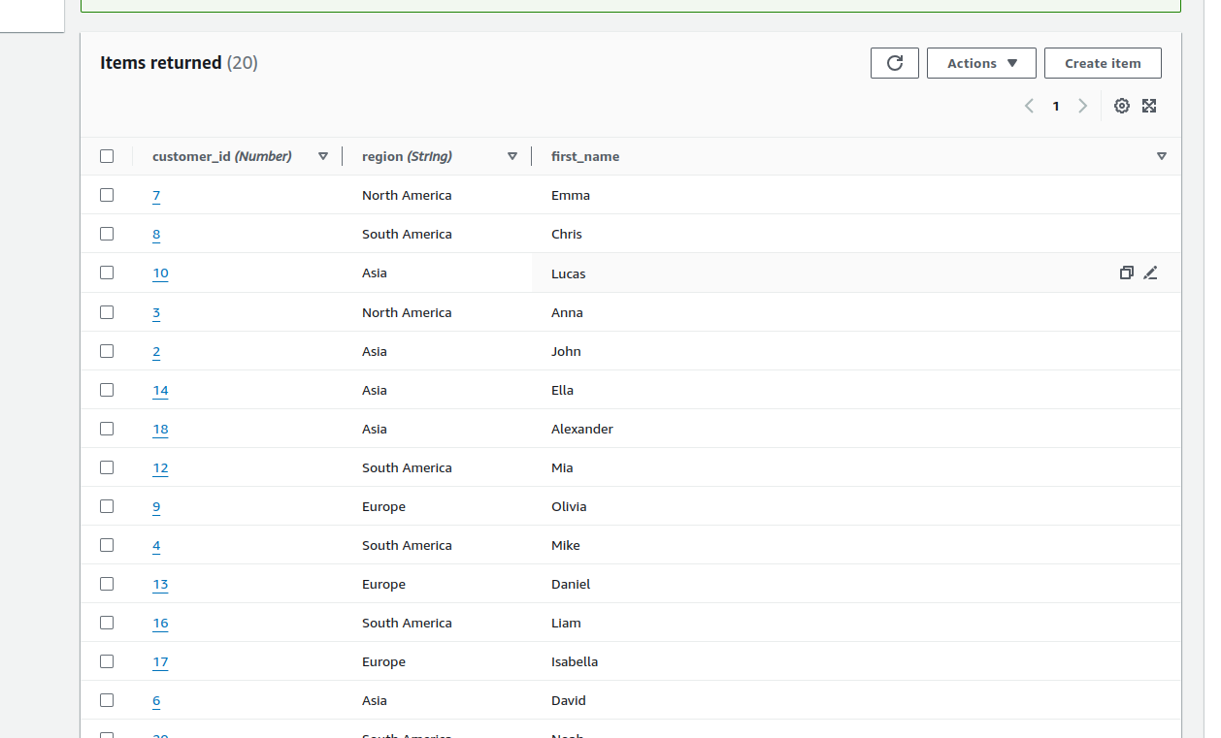.

Same approach for retriving data`

